Experiment 22
Aim:
To write a Prolog program to determine whether a particular bird can fly or not using facts and rules.
Algorithm:
- Define the birds as facts.
- Define birds that can fly.
- Define birds that cannot fly.
- Create rules flies/1 and does_not_fly/1.
- Run queries with a particular bird name.
- Prolog returns true if the condition is satisfied.
code

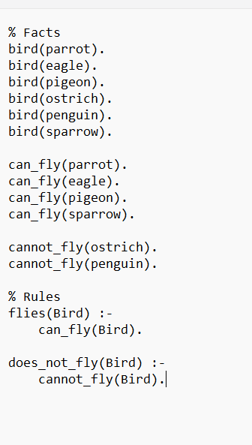
Output:
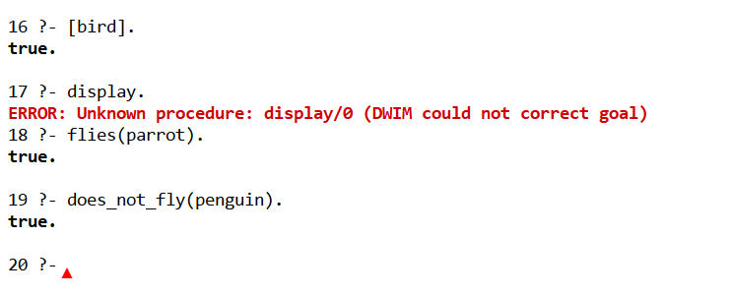
Result:
Thus the prolog program to determine whether a particular bird can fly or not using facts and rules.

